# A micro-computed tomography database and reference implementation for computation of trabecular thickness and spacing

# Authors

Thu Nguyen1,2, Andreas Höfter1, Kevin Leonardic1, Stefanie Rosenhain1,3, Fabian Kiessling3,4,5, Wannida Sae-Tang2, Uwe Naumann6, Felix Gremse1,3

## Affiliations

1. Gremse-IT GmbH, Dennewartsstr. 25, 52068 Aachen, Germany

2. The Sirindhorn International Thai-German Graduate School of Engineering, King Mongkut's University of Technology North Bangkok, Thailand

3. Experimental Molecular Imaging, Forckenbeckstr. 55, 52074 Aachen, RWTH Aachen University, Faculty of Medicine, Aachen, Germany

4. Comprehensive Diagnostics Center Aachen, Pauwelsstr. 30, 52074 Aachen, Germany

5. Fraunhofer MEVIS, Institute for Medical Image Computing, Forckenbeckstr. 55, 52074 Aachen, Germany

6. Software and Tools for Computational Engineering, RWTH Aachen University, 52062, Aachen, Germany

Corresponding author: Felix Gremse

# Abstract

The mechanical function of bones is maintained by trabeculae, a network of plates, struts, or rods. The correct assessment of trabecular thickness and spacing plays an important role in bone medicine for disease prognosis. There are several mechanisms to approximate trabecular thickness, but the obtained results require long computation times for large datasets. Additionally, the computed results can vary up to 10% and thus, are not very reliable. For a faster and accurate implementation, a well-defined procedure to calculate trabecular thickness is necessary. In this publication, we provide a database of three-dimensional trabecular bone micro-computed tomography (µCT) scans and a reference implementation, the brute force method, for accurate trabecular thickness measurements. This algorithm follows the volume-based thickness definition which is used by other popular methods, to confirm the validation of data. We encourage scientists to implement faster and accurate algorithms to compute trabecular thickness and re-employ the provided data to evaluate the accuracy of their methods in accordance with the brute force algorithm. The brute force code is freely available, and the trabecular bone data are shared in the online repository ‘Figshare’.

# Background & Summary

Many metabolic and endocrine diseases like primary hyperparathyroidism, hyperthyroidism, and Cushing's syndrome lead to the loss of bone mass, which, depending on its stage, is causing osteopenia or osteoporosis1–3. Parameters of the bone architecture provide important information to identify bone problems, helping to diagnose bone diseases in early stages correctly. Trabecular thickness (Tb.Th) and trabecular spacing (Tb.Sp), two important characteristics of bone morphology, which are the average thickness of bone and nonbone respectively, are used to assess the effectiveness of bone forming agents of patients with osteoporosis4–8. Previous studies used diverse methods to measure trabecular thickness, resulting in different, non-reliable results. Standardization of trabecular thickness measurement is of paramount importance, consequently, trabecular thickness should be computed by a well-defined procedure.

The classical method to calculate the trabecular thickness is histomorphometry5. Thereby the thickness is calculated indirectly as a half of the bone area divided by the perimeter5. This method can be incorrect, for example, when obtained points and intersections for the area and perimeter measurements are not sufficient. Cruz-Orive et al. proposed the surface-based measurement of trabecular thickness with a model assumption, in which the trabecular thickness at any point is measured by the distance from that point to the opposite surface9. However, this surface-based definition tends to induce inaccuracy problems for arbitrary and nonideal structures. To assess the thickness of any two-dimensional object of any shape, Garrahan et al. introduced a solution to estimate the local thickness by fitting the maximal circles to every point in the structure10. A similar method for three-dimensional structure analysis was developed by Hildebrand and Rüegsegger and applied in the well-known open source software BoneJ by using the definition of the volume-based thickness6,8,11. In that way, the local thickness at one point is computed as the diameter of the greatest sphere that fits within the structure and contains the point. A local thickness map is then created from local thicknesses of all points, which are shown as intensities of the map. In turn, the average trabecular thickness is defined as arithmetic mean value of the local thicknesses at all points in the object. This algorithm shows good performance for extraction of the quantitative values with high resolution and informative inputs such as micro-computed tomography (µCT). In comparison with commercial software such as CT Analyser and Scanco, BoneJ gives similar results of trabecular thickness measurements with variations of around 10%, but there is no clear evidence for the accurate outcomes8. In order to produce correct and verified measurements from bone µCTs, which is confirmed below, Gremse et al. implemented a graphics processing unit(GPU)-accelerated tool for bone trabecular thickness calculations7. This tool, named Imalytics Preclinical (Imalytics), is also for interactive segmentations in medical imaging.

In this work, we present a micro-computed tomography database as well as the reference implementation for accurate trabecular thickness computation, which is computed with the brute force method according to the volume-based thickness definition of Hildebrand and Rüegsegger. From that, we can validate the dataset by verifying the degree of accuracy of trabecular thickness measurement of Imalytics and BoneJ.

The brute force method for trabecular thickness measurement is to calculate exhaustively thickness of every point according to the volume-based thickness concept without any heuristic approximation. The computation of the brute force method has the time complexity O(2n6) and then, is a very time-consuming procedure. It requires 2*1018 operations to process a µCT trabecular bone scan 1000 x 1000 x 1000, and thus, needs 14 years on a personal computer to complete computing the local thickness map. Therefore, we encourage researchers to improve methods to calculate faster and correctly trabecular bone thickness and spacing and to verify the accuracy of their methods by using the provided standard dataset and the reference implementation.

# Methods

The dataset was cropped from a µCT scan of a sheep femur with 1600 x 1600 x 800 equilateral voxels, which was acquired by a U-CT (MILabs B. V., Utrecht, The Netherlands) and scanned using a voltage of 55 kV and a current of 0.17 mA with 1440 projections. Three-dimensional bone images were cut at varying positions of the µCT scan by using the software Imalytics Preclinical (Gremse-IT GmbH, Aachen, Germany) to get different rectangular forms, which have distinct trabecular thickness and spacing as illustrated in the figure 1.

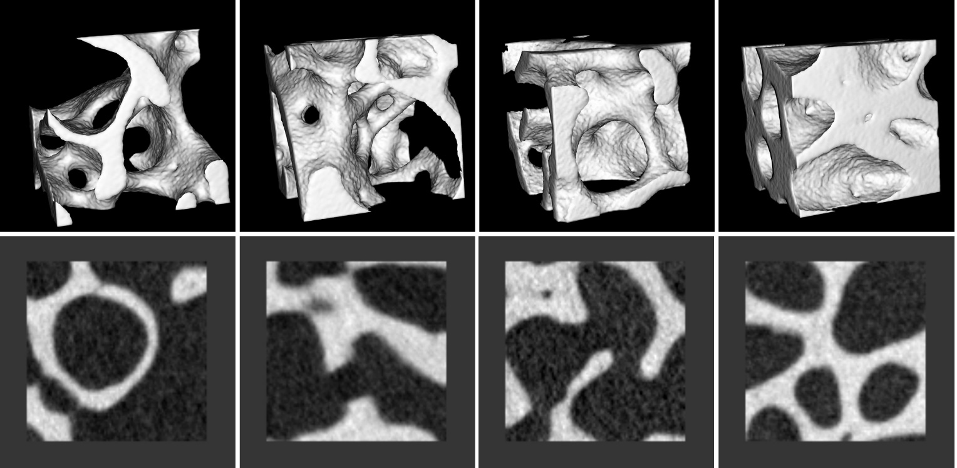

**Figure 1. Examples of bone images with different forms and trabecular thickness**. 3D rendering (upper panel) and 2D axial slice view (lower panel), respectively.

**Segmentation**

Since BoneJ, Imalytics and the brute force method require a binary mask as an input, the bone images are segmented by using the single thresholding segmentation. The thresholding value is selected independently as 2000. The binary mask result includes trabecular bone as the foreground and the none-bone part as the background and is also attached in the dataset as stated in the section Data Record.

**Brute force implementation**

*Data pre-process*

The input data is up-sampled by two to reduce the voxel effect, improving the correctness of thickness measurement. The voxel size is decreased twice subsequently, and the voxel grid becomes finer.

*Thickness measurement*

In order to calculate the local thickness map according to the volume-based thickness definition, it is practical to firstly create the distance map of a binary input mask of the object, in which the Euclidean distance to the closest background voxel is shown as intensities of the map6. From the distance map, the local thickness map can be computed accordingly. The local thickness at point $\overline{p}$ is equal to double the highest intensity, point $\overline{q}$, in the distance map that is bigger than the Euclidean distance between those two points as the following formulas:

$DM\left(\overline{p}\right)=\min_{\overline{x}\text{∉} \text{Ω}}\left(|\overline{p}-\overline{x}|\right)$ (1)

$LTM\left(\overline{p}\right)=2\max_{\overline{q}∈\text{ Ω}}\left(DM(\overline{q}) | DM(\overline{q}) + ε >|\overline{p}-\overline{q}|\right)$ (2)

where $\overline{p}$, $\overline{q}$ are points in the object, $\overline{x}$ is a point outside the object, DM ($\overline{p}$) is the distance map at the point $\overline{p}$, LTM($\overline{p}$) is the local thickness at the point , Ω ϵ R3 is the set of all points in the object, || is the Euclidean distance between $\overline{p}$ and , | - | is the Euclidean distance between $\overline{p}$ and $\overline{q}$, and $ε$ is a defined error, an important factor to count border voxels, which are close to the surfaces of spheres. $ε$ = 0.5 is selected experimentally as the best value of $ε$ to include accurately border voxels without a clean-up step as in BoneJ.

The brute force implementation repeats this procedure for every single voxel in the object. In other words, the brute force method follows exactly the volume-based thickness definition in every single step. Therefore, it provides very correct results and can be used as the reference output for trabecular thickness measurements.

**Code availability**

The brute force code implemented in C++ is available on Figshare. It contains 64 lines of code for the local thickness map calculation, 66 lines of code for distance map calculation and 1970 lines of code for helper functions in C++. In addition, we used the commercially available software Imalytics Preclinical 2.1 (Gremse-IT GmbH, Aachen, Germany) and the open source plugin BoneJ 2 integrated into the tool ImageJ 2.0 for the experiments to validate the trabecular thickness measurements over the dataset.

# Data Record

Our introduced database consists of 40 three-dimensional bone images in the nifti file format (.nii) with the image size of 100 x 100 x 100 voxels and the voxel size of 20 x 20 x 20 µm. Along with each bone image, the following data with the same dimensions, which are computed by both the brute force method, Imalytics Preclinical, and BoneJ, are also available. Thereby, every folder contains the following files:

1. One original bone image (Trabecular.nii, 16-bit long)
2. One binary mask (BinaryMaskBruteforce.nii, 8-bit unsigned integer)
3. One distance map for trabecular thickness from the brute force method (DMThicknessStandardBruteforce.nii, 32-bit float)
4. One distance map for trabecular thickness from the brute force method (DMThicknessSuperBruteforce.nii, 32-bit float)
5. One distance map for trabecular thickness from BoneJ (DMThicknessStandardBoneJ.nii, 32-bit float)
6. One local thickness map for trabecular thickness from the brute force method (LTMThicknessStandardBruteforce.nii, 32-bit float)
7. One local thickness map for trabecular thickness from the brute force method (LTMThicknessSuperBruteforce.nii, 32-bit float)
8. One local thickness map for trabecular thickness from BoneJ (LTMThicknessStandardBoneJ.nii, 32-bit float)
9. One distance map for trabecular spacing from the brute force method (DMSpacingStandardBruteforce.nii, 32-bit float)
10. One distance map for trabecular spacing from the brute force method (DMSpacingSuperBruteforce.nii, 32-bit float)
11. One distance map for trabecular spacing from BoneJ (DMSpacingStandardBoneJ.nii, 32-bit float)
12. One local thickness map for trabecular spacing from the brute force method (LTMSpacingStandardBruteforce.nii, 32-bit float)
13. One local thickness map for trabecular spacing from the brute force method (LTMSpacingSuperBruteforce.nii, 32-bit float)
14. One local thickness map for trabecular spacing from BoneJ (LTMSpacingStandardBoneJ.nii, 32-bit float)

|  |  |  |
| --- | --- | --- |
| ****Sample number**** | ****Thickness by Brute Force Method [µm]**** | ****Spacing by Brute Force Method [µm]**** |
| 1 | 686 | 3402 |
| 2 | 901 | 326 |
| 3 | 830 | 1260 |
| 4 | 301 | 657 |
| 5 | 548 | 404 |
| 6 | 271 | 1301 |
| 7 | 332 | 603 |
| 8 | 556 | 731 |
| 9 | 1006 | 447 |
| 10 | 806 | 504 |
| 11 | 820 | 348 |
| 12 | 749 | 415 |
| 13 | 331 | 880 |
| 14 | 260 | 1046 |
| 15 | 517 | 470 |
| 16 | 246 | 779 |
| 17 | 352 | 529 |
| 18 | 347 | 705 |
| 19 | 402 | 627 |
| 20 | 530 | 643 |
| 21 | 1261 | 723 |
| 22 | 269 | 889 |
| 23 | 1256 | 655 |
| 24 | 1045 | 430 |
| 25 | 296 | 908 |
| 26 | 459 | 539 |
| 27 | 701 | 1115 |
| 28 | 1469 | 832 |
| 29 | 841 | 394 |
| 30 | 1281 | 185 |
| 31 | 594 | 815 |
| 32 | 701 | 677 |
| 33 | 578 | 514 |
| 34 | 317 | 669 |
| 35 | 455 | 473 |
| 36 | 953 | 3790 |
| 37 | 236 | 1172 |
| 38 | 460 | 485 |
| 39 | 463 | 482 |
| 40 | 429 | 534 |

**Table 1. Characterization of the dataset.** The table shows the trabecular thickness and trabecular spacing in mm of every bone image.

# Technical validation

To validate the dataset, the experiments were carried out with the trabecular spacing and thickness measurements of the brute force method, BoneJ, and Imalytics over the dataset and the reliable results are provided as a reference. We could show that the dataset is diverse and suitable to assess the accuracy of methods to measure trabecular thickness and spacing.

First, we prove that the brute force method generates the more correct output by testing it with a dataset of spheres. A dataset of spheres is created with multiple uniform sphere-cubes, where a sphere is inside a cube. The intensity of sphere, or foreground, is 200 and intensity of the cube, or background is 0. The sphere plays a role as a trabecular inside the structure, and the cube plays a role of the remaining parts of bone. Moreover, the diameter of the sphere is supposed to equal to the local thickness map by the volume-based thickness definition. Thus, the sphere-cube data is well-suited for this experiment of trabecular bone. A single sphere is created by defining a center and filling the sphere with points, that has the distance smaller than radius. The super oversampling method is applied with the factor 64 for filling correctly points in spheres and then down-sampling is used to produce spheres with the expected voxel sizes. Consequently, the edge voxels have different intensity levels and make spheres in a more correct shape.

The performance of the brute force method, BoneJ and Imalytics are analyzed by exploiting upsampling by two on the dataset of spheres. Imalytics and BoneJ generates the same measures regardless of the size of sphere with both upsampling and without upsampling. In addition, the figure 2 illustrates that the super brute force method, or the brute force method with upsampling by two, produces results closer to the diameter of a sphere, called the known thickness value, than the brute force method without upsampling, namely the standard brute force method. The enhancement is presented obviously for small spheres with the size in range from 4 voxels to 20 voxels. The differences between the known values and the results of super brute force method decrease and approximate 0 when the mean thickness increases. However, for the range from 4 voxels to 7 voxels, the super brute force method does not show the good performance, of which the deviation is from 4% to 13%. Similarly, results of the BoneJ with upsampling, called super BoneJ, is more accurate than those of BoneJ without upsampling, namely standard BoneJ. Therefore, the upsampling step contributes greatly to the improvement of the accuracy of the thickness measurement. The super brute force method, always gives more correct outputs than the standard BoneJ, which was developed by Hildebrand and et al..

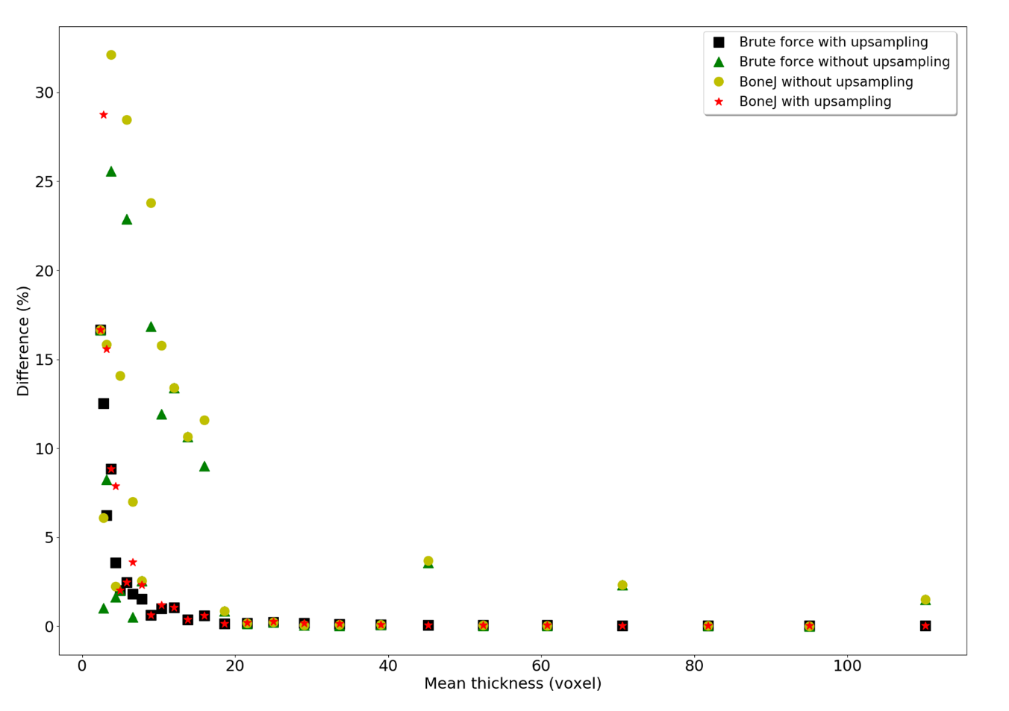

**Figure 2.** Thickness differences between the known values and the brute force method, BoneJ

The standard brute force method, standard Imalytics, and standard BoneJ all accept the same input masks and produce the same distance maps for both trabecular thickness and trabecular spacing on the whole image dataset. The local thickness maps of Imalytics are identical to those of the standard brute force method as expected since Imalytics is a GPU-accelerated version of the standard brute-force implementation. Also, the local thickness maps of standard BoneJ are similar to those of the standard brute force method with small differences.

Likewise, the figure 3a & b demonstrate the strong correlation between the standard BoneJ and the super brute force method for trabecular thickness and trabecular spacing over 40 bone images, of which the ranges of trabecular thickness and spacing are from 236 **µm** to 1469 **µm** and 326 **µm** to 3790 **µm** correspondingly. The coefficient of correlation R and coefficient of determination R2 of thickness mean and spacing mean are 0.98193 (R236-1469), 0.99983 (R²236-1469) and 0.9977 (R326-3790), 0.99957 (R²326-3790) respectively, which reflects well the small difference between the super brute force method and the standard BoneJ. In line with this, the Bland-Altman Plot in figure 3c suggests that difference between average trabecular thicknesses of the super brute force implementation and the standard BoneJ is varying with regard to means of average trabecular thicknesses over the whole dataset. The variation of the difference ranges from 2.18 **µm** to over 30.27 **µm**, when the mean value changes from about 236 **µm** to 1469 **µm**. The difference remains small when the mean of trabecular thicknesses is small. The trabecular thickness results of the standard BoneJ tend to be lower than those of the super brute force method correspondingly, which is in a strong agreement with the previous analysis. Similarly, in trabecular spacing, values calculated by the standard BoneJ are lower than by the super brute force method while super Imalytics and the super brute force method give the same results. These facts emphasize that the provided dataset is well-suited to examine the accuracy of trabecular thickness and spacing assessments according to the brute force implementation.

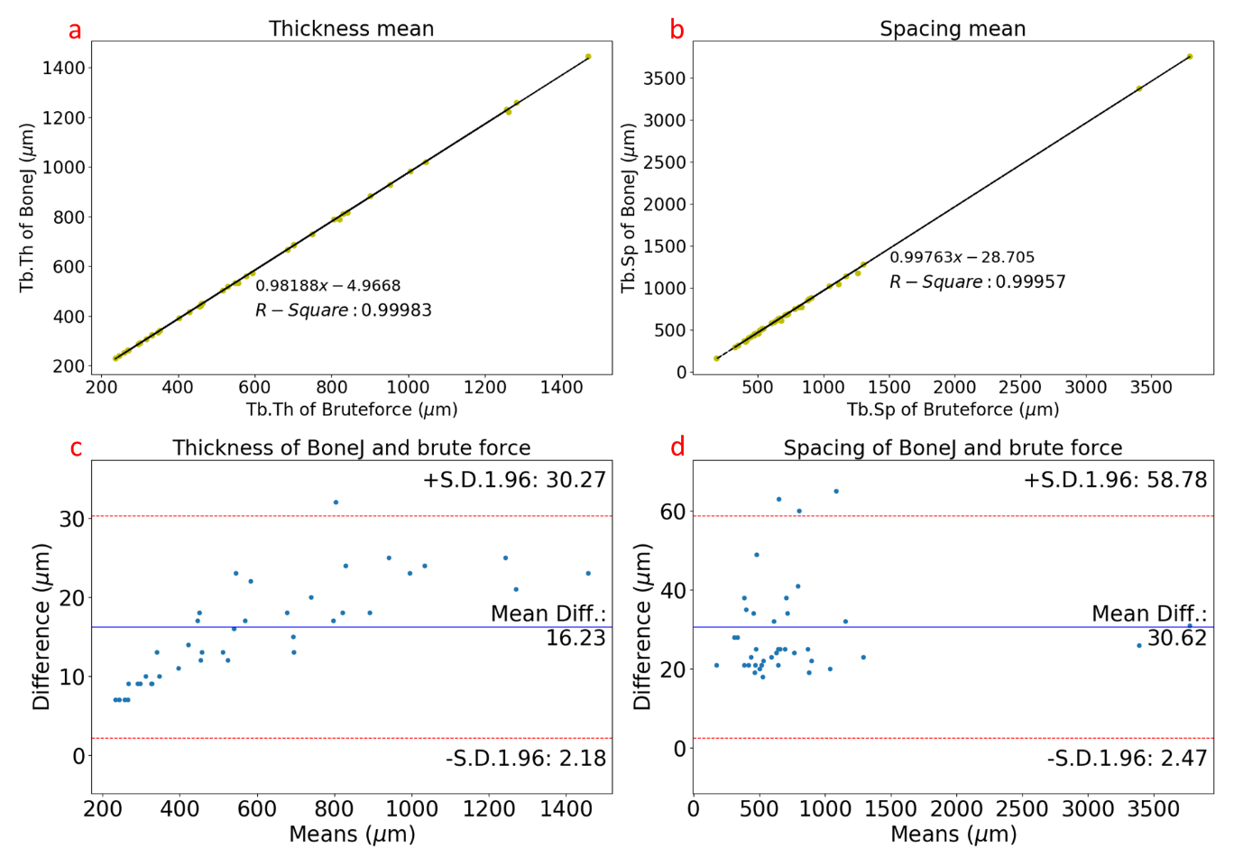

**Figure 3.** **Comparison between the trabecular thickness calculation results of methods.** **a**) Correlation between the super brute force method and standard BoneJ in trabecular thickness. **b**) Correlation between the super brute force and standard BoneJ in trabecular spacing. **c**) Bland-Altman Plot on the differences between the super brute force method and standard BoneJ in average trabecular thickness in regard to means of these average trabecular thicknesses. **d**) Bland-Altman Plot on the super brute force method and standard BoneJ in trabecular spacing.

# Usage Notes

Researchers are encouraged to download the single scans or the whole database from Figshare (Data citation). Dataset usage is especially for evaluation of the accuracy of methods to assess trabecular thickness and spacing. The trabecular thickness results of future methods can be compared with those of the brute force method over the whole dataset in order to get the distribution of their difference over a range of data. The intermediate data from the dataset such as binary masks, distance maps, and local thickness maps of the brute force method can also be used to verify intermediate steps of the future methods.

# Acknowledgements

This work is supported by Gremse-IT GmbH and the organization German Academic Exchange Service.

# Author contributions

T.N. produced the data, executed the experiments and wrote the manuscripts. T.N., K.L. and A.H. implemented the brute force code. S.R, W.S, F.K, U.N. and F.G. reviewed the manuscript. F.G. supervised and directed the general work.

# Competing interests

F. Gremse is the owner of Gremse-IT GmbH and works for MILabs B.V. as consultant. The other authors declare no competing interests.

# Data citation

Nguyen, Thi Ngoc Thu; Höfter, Andreas; Rosenhain, Stefanie; Gremse, Felix (2019): Three-dimensional Trabecular Bone Images. figshare. Dataset [**https://doi.org/10.6084/m9.figshare.7932254**](https://doi.org/10.6084/m9.figshare.7932254)

# Reference

1. Rosen, C. Endocrine disorders and osteoporosis. *Curr Opin Rheumatol.* **9**, (1997).

2. Muka, T. *et al.* The Association between Metabolic Syndrome, Bone Mineral Density, Hip Bone Geometry and Fracture Risk: The Rotterdam Study. *PLoS One* **10**, (2015).

3. Lau, R. & Guo, X. A Review on Current Osteoporosis Research: With Special Focus on Disuse Bone Loss. *Journal of Osteoporosis* **2011**, (2011).

4. Tanaka, Y., Nakayamada, S. & Okada, Y. Osteoblasts and osteoclasts in bone remodeling and inflammation. *Current Drug Targets - Inflammation & Allergy* **4**, 325–328 (2005).

5. Parfitt, A. M., Mathews, C. H. E. & Villanueva, A. R. Relationships between Surface, Volume, and Thickness of Iliac Trabecular Bone in Aging and in Osteoporosis. *J. Clin. Invest* **72**, 1396–1409 (1983).

6. Hildebrand, T. & Rüegsegger, P. A new method for the model-independent assessment of thickness in three-dimensional images. *Journal of Microscopy* **185**, 67–75 (1997).

7. Gremse, F. *et al.* Imalytics Preclinical: Interactive Analysis of Biomedical Volume Data. *Theranostics* **6**, 328–341 (2016).

8. Doube, M. *et al.* BoneJ: Free and extensible bone image analysis in ImageJ. *Bone, Elsevier* 1076–1079 (2010).

9. Cruz-Orive, L. M. Estimation of Sheet Thickness Distributions from Linear and Plane Sections. *Biom. J* **21**, 717–730 (1979).

10. Garrahan, N. J., Mellish, R. W. E., Vedi, S. & Compston, J. E. Measurement of Mean Trabecular Plate Thickness by a New Computerized Method. *Bone* **8**, 227 – 230 (1987).

11. Hildebrand, T., Laib, A., Müller, R., Dequeker, J. & Rüegsegger, P. Direct Three-Dimensional Morphometric Analysis of Human Cancellous Bone: Microstructural Data from Spine, Femur, Iliac Crest, and Calcaneus. *Journal of Bone and Mineral Research* **14**, (1999).

12. Saha, P. K. & Wehrli, F. W. Measurement of Trabecular Bone Thickness in the Limited Resolution Regime of In Vivo MRI by Fuzzy Distance Transform. *IEEE Transactions on Medical Imaging* **23**, (2004).

13. Mccoll, D. J., Abel, R. L., Spears, I. R. & Macho, G. A. Automated Method to Measure Trabecular Thickness From Microcomputed Tomographic Scans and Its Application. *The Anatomical Record* 982–988 (2006).

14. Dougherty, R. P. & Kunzelmann, K. Computing Local Thickness of 3D Structures with ImageJ. *Microscopy & Microanalysis* (2007).

15. Parfitt, A. M. *et al.* Bone histomorphometry: Standardization of Nomenclature, Symbols, and Units. *Journal of Bone and Mineral Research* **2**, 595–610 (1987).

16. Mannheim, J. G. *et al.* Standardization of Small Animal Imaging—Current Status and Future Prospects. *Molecular Imaging and Biology* **20**, 716–731 (2017).

17. Huang, H. L. *et al.* Three-dimensional bone structure and bone mineral density evaluations of autogenous bone graft after sinus augmentation: a microcomputed tomography analysis. *Clinical Oral Implants Research* 1098–1103 (2011).

18. Kim, Y. J. & Henkin, J. Micro-Computed Tomography Assessment of Human Alveolar Bone: Bone Density and Three-Dimensional Micro-Architecture. *Clinical Implant Dentistry and Related Research* **17**, 307–313 (2015).

19. Salmon, P. L., Ohlsoon, C., Shefelbine, S. J. & Doube, M. Structure model index does not measure rods and plates in trabecular bone. *Frontiers in Endocrinology* **6**, (2015).

20. Rosenhain, S. *et al.* A preclinical micro-computed tomography database including 3D whole body organ segmentations. *Scientific Data* (2018). doi:10.1038/sdata.2018.294

21. Saito, T. & Toriwaki, J. New Algorithms for Euclidean Distance Transformation of an n-Dimensional Digitizied Picture with Applications. *Pattern Recognition* **27**, 1551–1565 (1994).